Sohan M 1NT19IS155

Aggregate Functions

db.sohan.aggregate([{$match:{dept:"ISE"}},{$count:"Total students in ISE"}])

db.sohan.aggregate([{$match:{dept:"CSE"}},{$count:"Total students in ISE"}])

Maximum Marks

> db.sohan.aggregate([{$group :{_id:"$dept", max_marks:{$max:"$marks"}}}])



Minimum Marks

db.sohan.aggregate([{$group :{_id:"$dept", min_marks:{$min:"$marks"}}}])



Greater Than

db.sohan.aggregate([{$match:{marks:{$gt:75}}}])
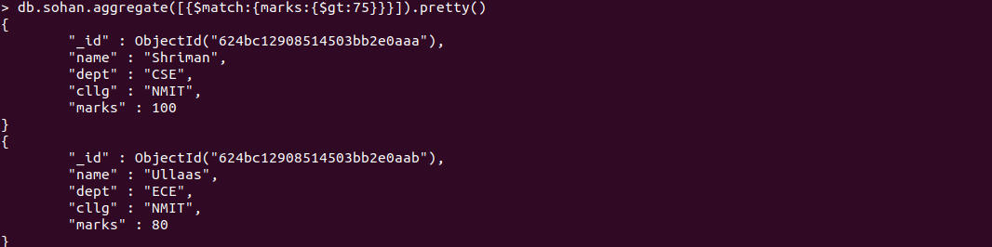
Less Than

db.sohan.aggregate([{$match:{marks:{$lt:70}}}])

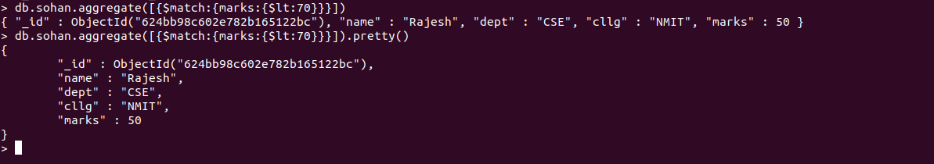

Sorting

db.sohan.aggregate([{"$sort":{"marks":1}}])

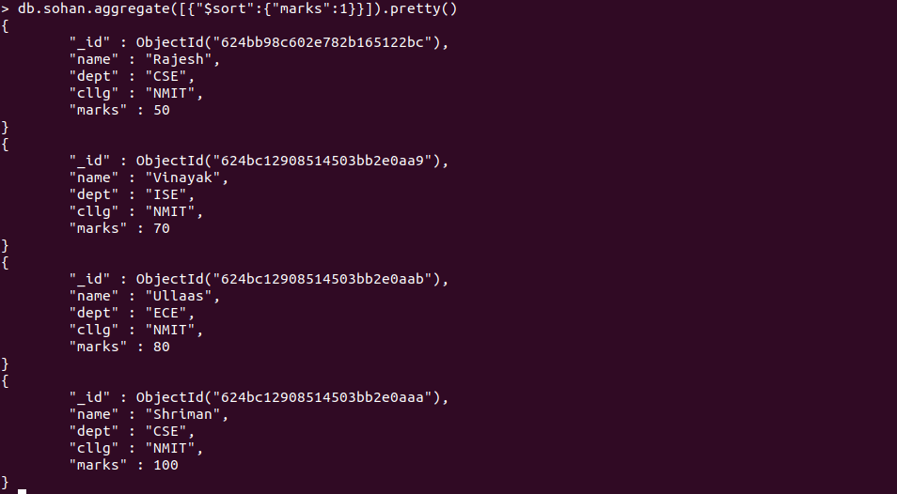
db.sohan.aggregate([{"$sort":{"marks":-1}}]).pretty()

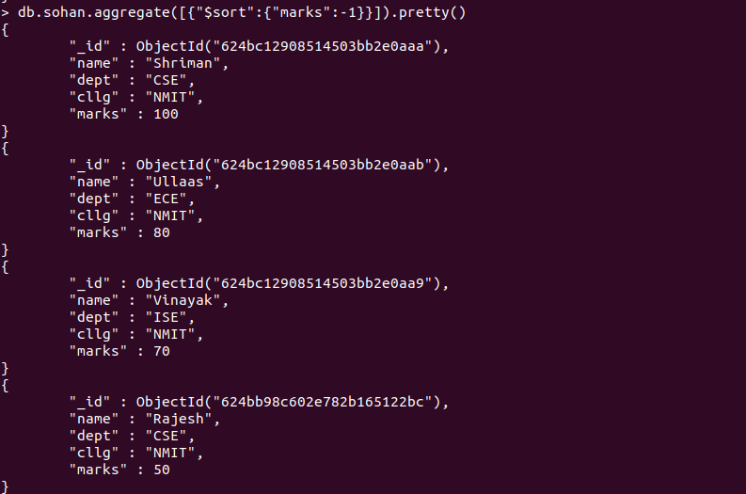

Sum

db.sohan.aggregate([{ $group:{ _id:null, total:{ $sum : "$marks"}}}])

Average

db.sohan.aggregate([{ $group:{ _id:null, total:{ $avg : "$marks"}}}])

